Home page
Stock Cabinetry Scroll Bar
We can make all tiles populate at the same size (height and width) they are a bit off
Stock cabinetry
-Remove specs from main page
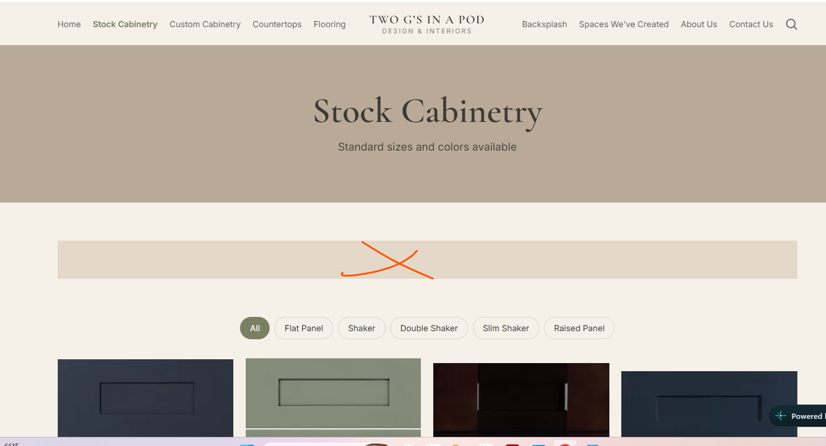
-keep specs on each individual page like we have now
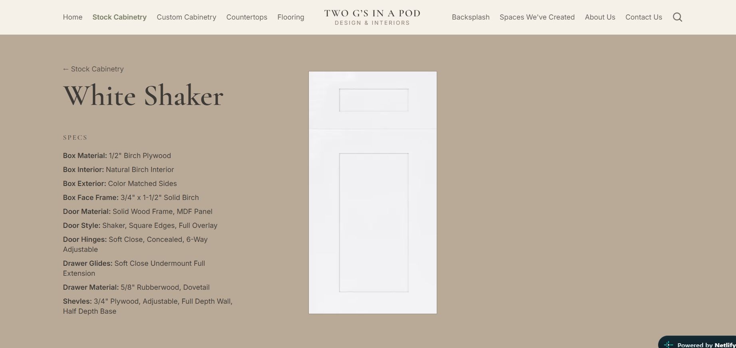

-Items, be able to click on item to pop up larger photo
Example click on B12 and there is a pop up with larger photo of item
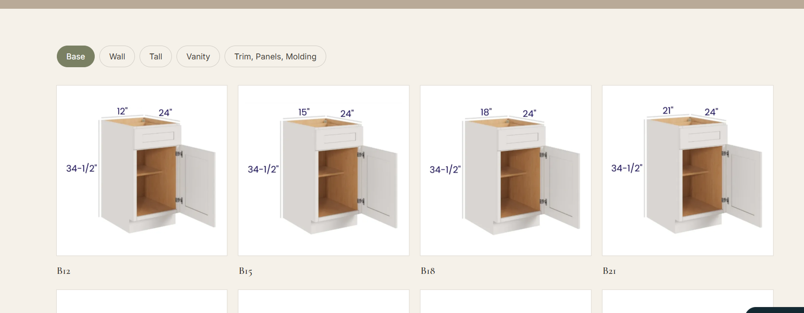

Custom Cabinetry
Main Categories Tab Add:
Polymer High-Gloss
Polymer Velour Touch
Master Oak
Will I be able to add tabs myself in the future?

Door Profiles
Add all tab
Remove other

Paints
Good!

Textured Melamine
-please put these files under textured melamine, they were under paints.
I removed them from paints but they need to be uploaded under textured melamine
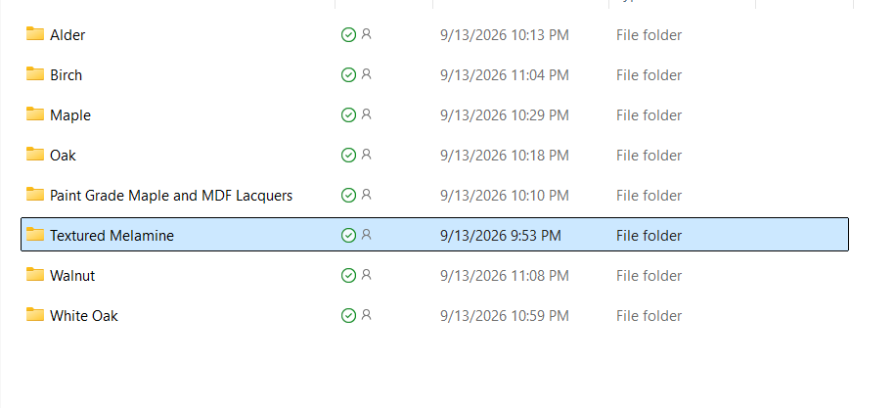
Countertops
-add all category to website

Backsplash
-add all category to website

Spaced we've created
Good!

Terms & conditions
-switch to bullet points like others, not asterisk
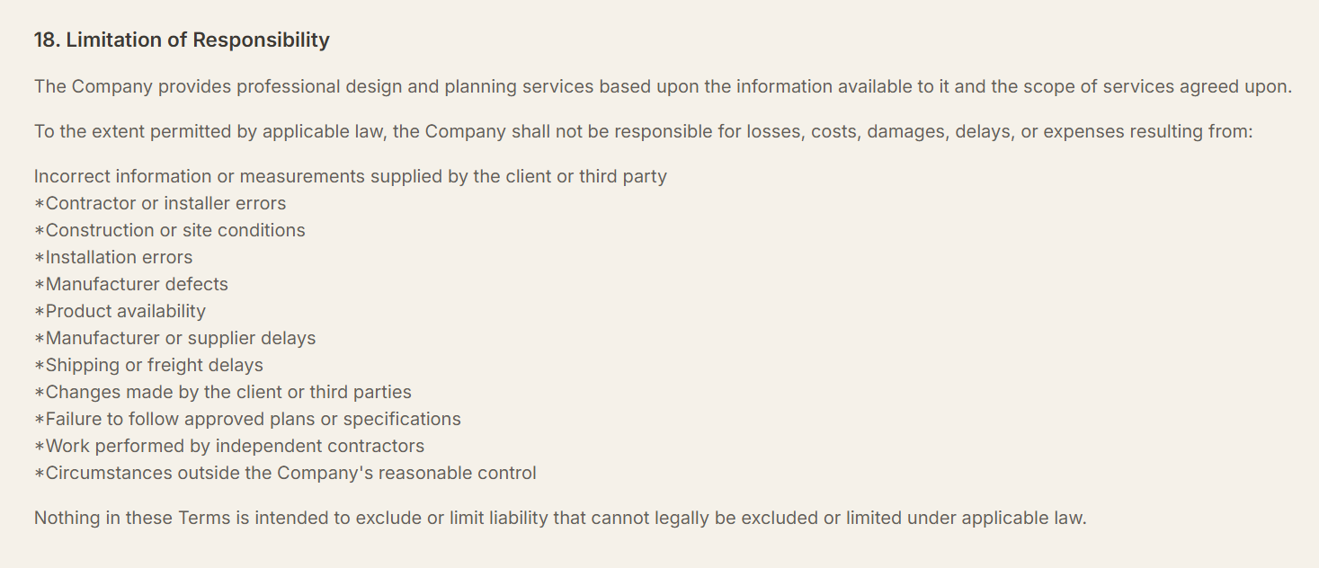

_____________________________________________________________________________

Admin panel

Stock cabinetry
ability to change items under each individual door style/color
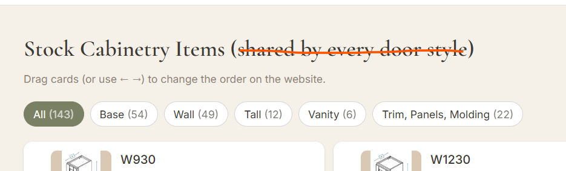
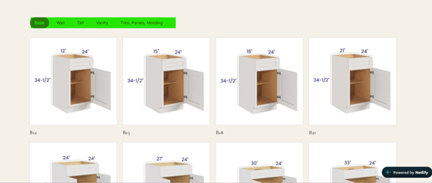

Can we add usual rows to stock cabinetry so I don’t have to manually input them all (see below)
(box material, box interior, box exterior, box face frame, door material, door style, door hinges, drawer glides, drawer material, shelves
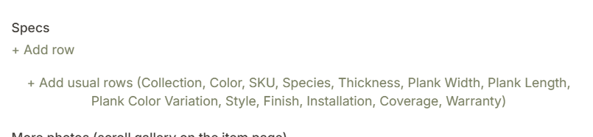
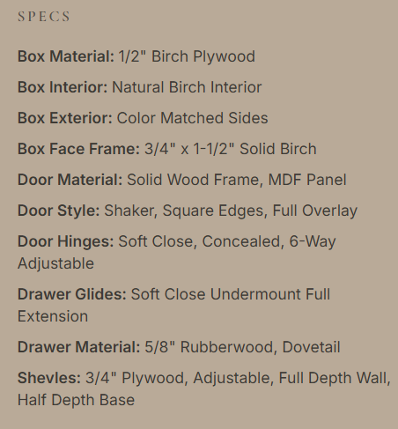

Custom - Door Profiles
For Category tab, I need to be able to select more than one category
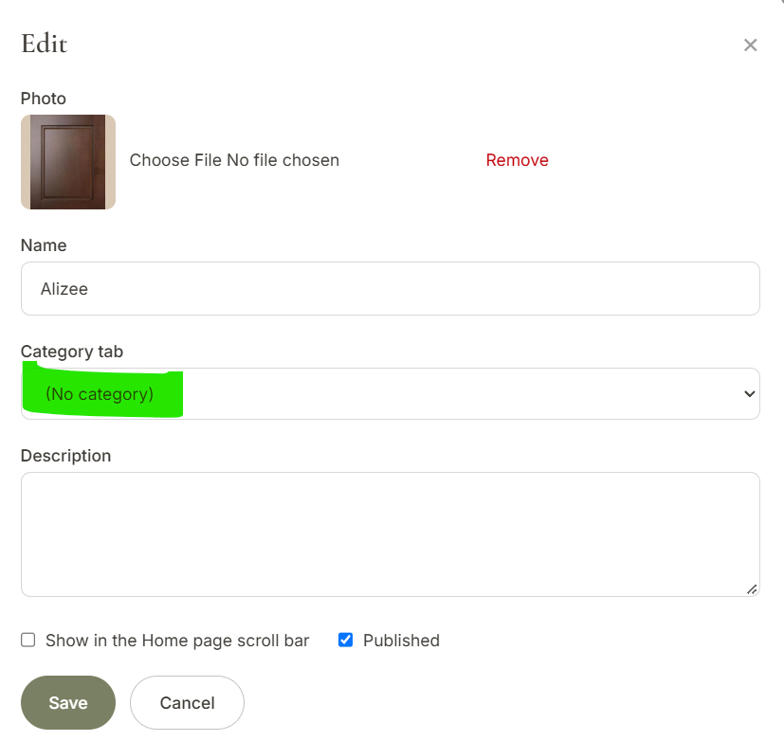

Measurement Guide
Page set up
Photo of measurement guide on left where headshot is
Description/wording can be on right like below
Clickable link “Measurement Guide” to download PDF measurement guide to print
*PDF sent to you via email
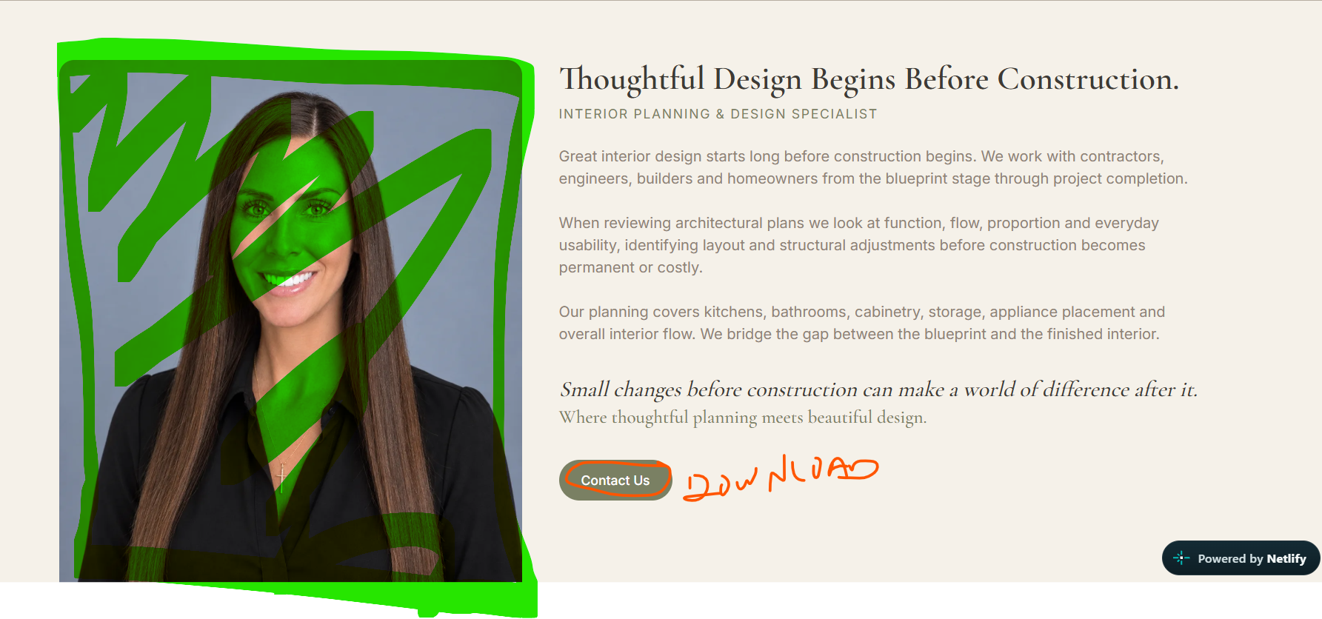

Site content
Good!

